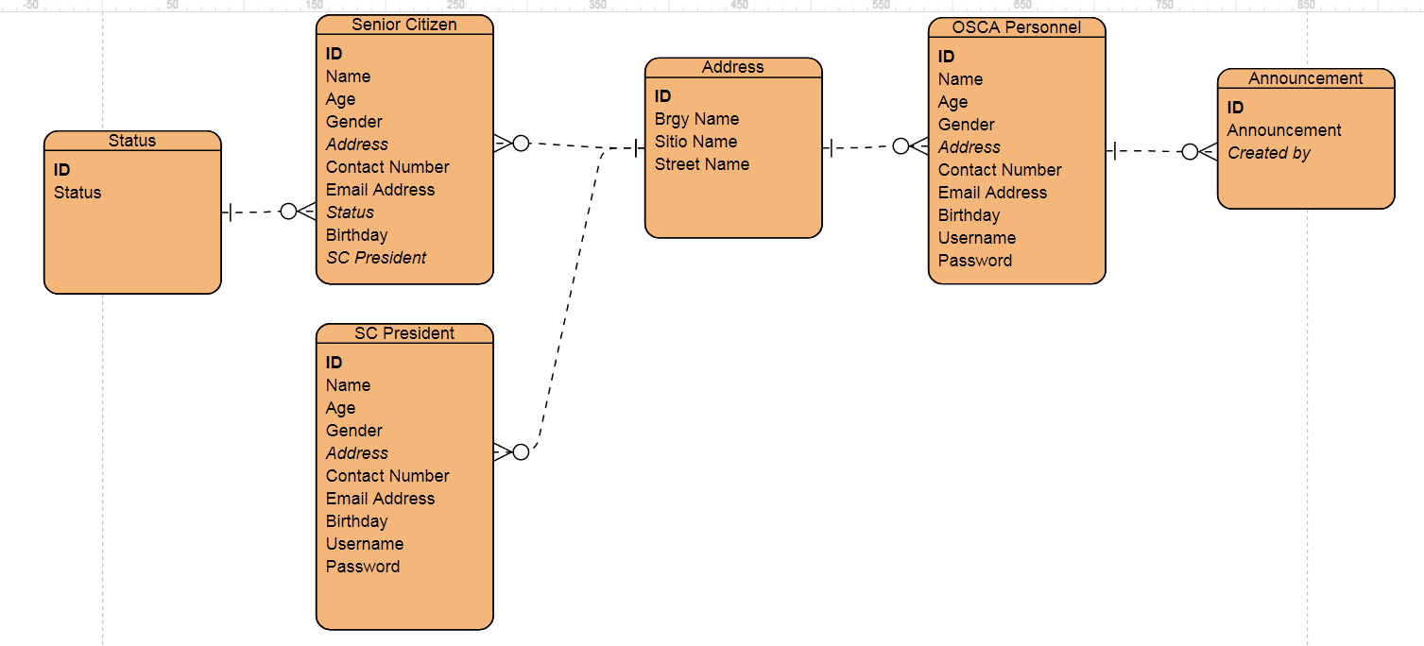PenSys Database Architecture

Sample Queries:

* SELECT * FROM Senior_Citizen WHERE Gender = “Female”
* SELECT * FROM Senior_Citizen WHERE Name = ‘$Search’
* SELECT * FROM Senior_Citizen WHERE Address LIKE %$Search%
* INSERT INTO Senior_Citizen VALUES ($Name, $Age, $Gender, …)
* SELECT COUNT * FROM Senior_Citizen WHERE SC_Pres = $Name